Personal Travel Blog Project Overview

# Objective:

The project aims to create a personal blog hosted on IBM Cloud Static Web Apps. The blog will feature travel stories, tips, and captivating photos to inspire and inform readers. The project involves the following key aspects:

# Personal Design

Define the blog's persona:

Determine the tone and style of communication, which may vary depending on the nature of the content. I was design minimal towards load easily on any device then loads perfectly on each devices.

# THIS COLUD BE THE OUTLINE OF THE WEBPAGE

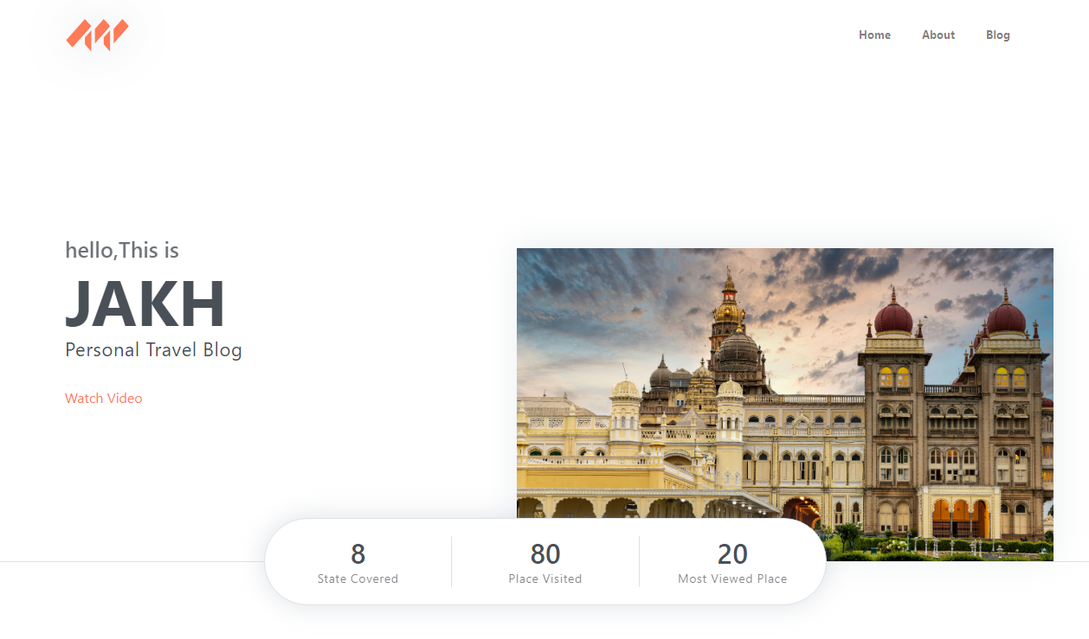

# 

# Content Planning

Structure the blog: Organize the blog's content into sections for travel stories, tips, photos, and possibly a **map showing visited places**.

Engagement: Include interactive elements like comments and social sharing buttons to encourage user interaction.

Most of content were from my friends. Because they may read many stories or many books so they can help to my blog’s content creation.

Me and my friends were plan the contents apart from the places. Because the content may change varies to the places.

# Content Creation

Write travel stories: Craft engaging and immersive travel narratives that capture the essence of the experiences and destinations.

Curate photos: Select and showcase captivating images that complement the stories and provide a visual representation of the journeys.

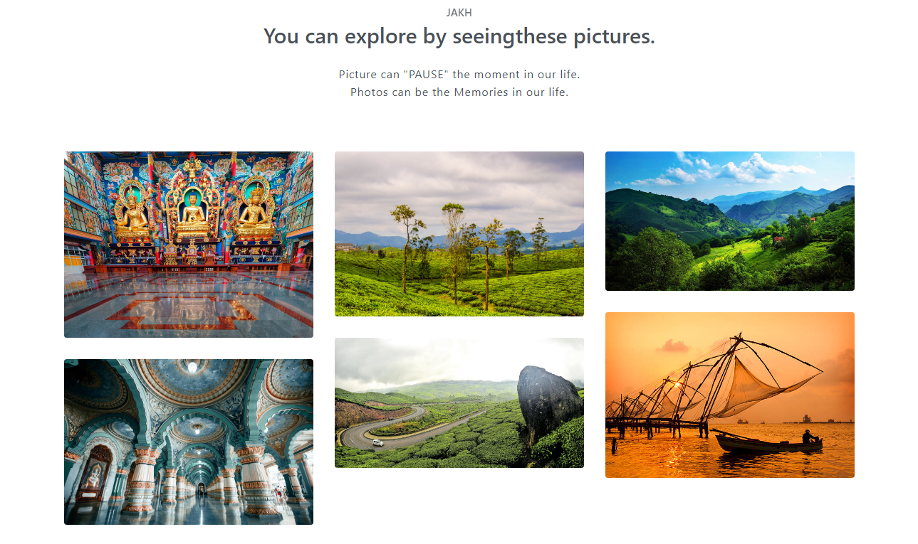

# Website Design

Design a visually appealing layout: Use HTML, CSS, and possibly JavaScript to create an attractive and user-friendly design.

Responsiveness: Ensure that the blog is responsive, adapting to various devices, including desktops, tablets, and mobile phones.

Interactivity: Implement interactive elements, such as image galleries and possibly maps to enhance user engagement.

# IBM Cloud Setup

- Create an IBM Cloud account: If not already done, register an account on IBM Cloud.

- Set up a Static Web App: Configure a Static Web App on IBM Cloud to host the blog.

- Continuous Deployment: Implement a continuous deployment process to streamline blog updates.

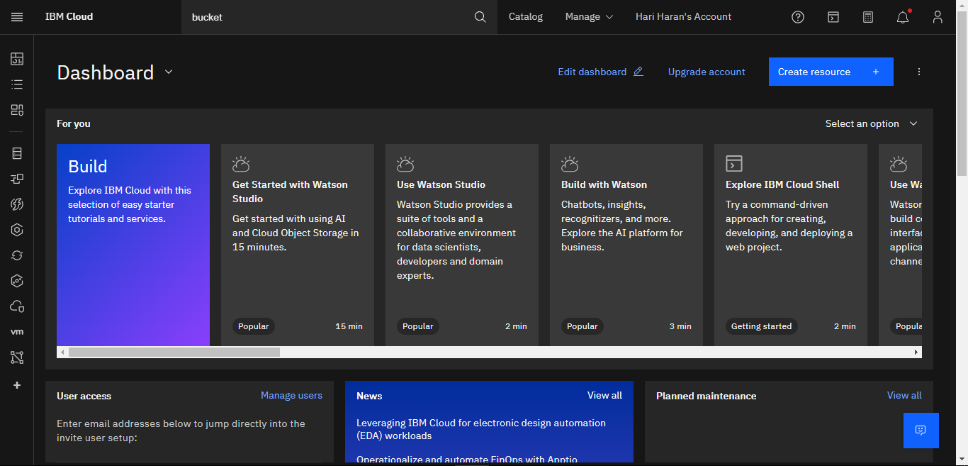

# 

# Content Management

Choose a content management system (CMS) or static site generator:

Select a suitable platform to facilitate easy content updates and management. Then we realise that content management was the one of the toughest way mange with our systems. Because they can’t stable at any time they were the low end of this year.so this may the toughest one to manage our content.

Establish a content update workflow:

Define a process for adding new stories and photos.

Version Control

: Implement version control, such as Git, to track changes and collaborate with contributors.

On the fit it can easy pull into our systems. Those are the easiest way to mange our content.

# System Requirements

Hardware Requirements

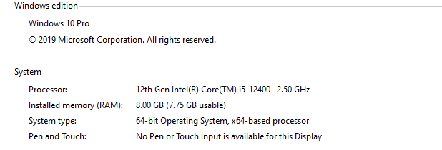

Software Requirements

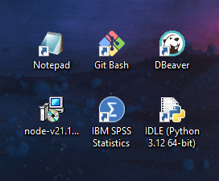

Development Phases

# Phase 1: Planning and Design

Define the blog's persona, tone, and style of communication. Then we started create an layout of the website by choosing colour by selecting by colour palette. Those colours should be minimal. Because if the colour was higher contrast the user can cause some itching on their eyes towards visiting many hours on the website.

Structure the blog's content, create categories, and plan interactive features. The structure of the blog must be in the similar way of minimal way on tone.

Design the layout and user interface for the blog. So I created “HOME-ABOUT-BLOG” .

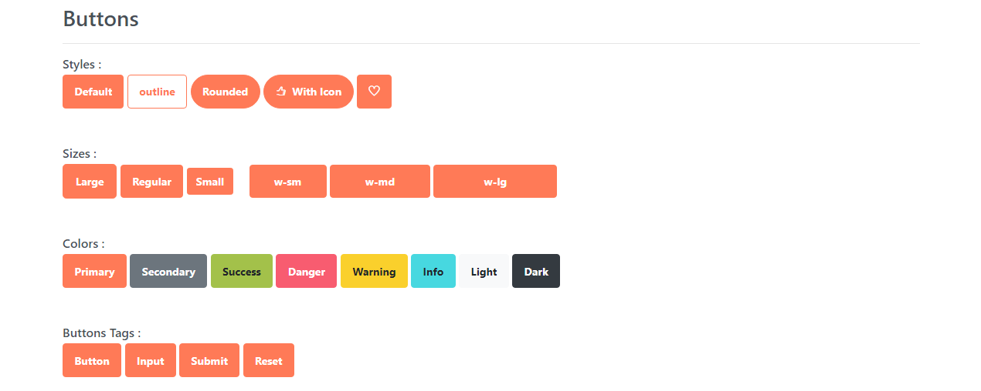

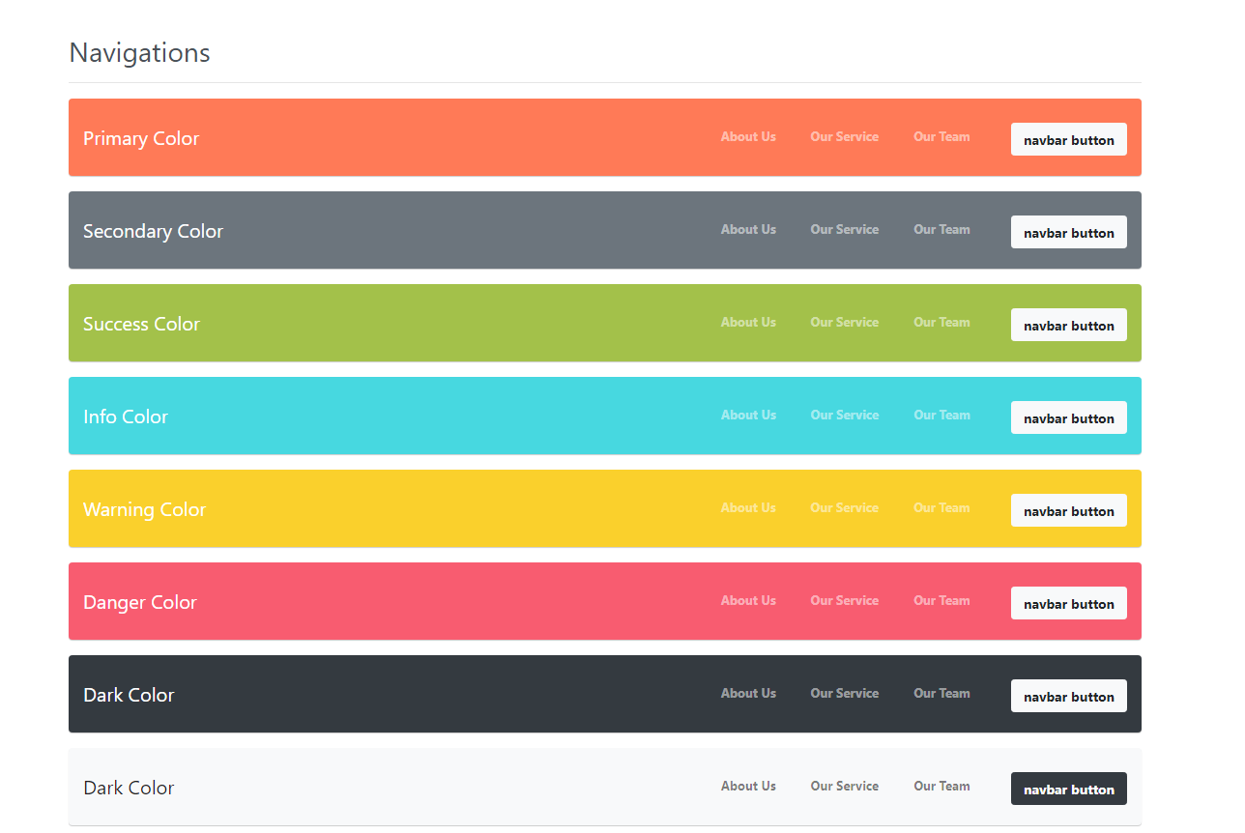

# Phase 2: Content Creation

- Begin writing travel stories and creating engaging content.

- Curate and edit photos for the blog posts.

- Compile and organize travel tips.

# Phase 3: Technical Implementation

- Create the blog's HTML, CSS, and, if necessary, JavaScript code for the web design.

- Set up an IBM Cloud account and configure the Static Web App to host the blog.

- Choose and implement a CMS or static site generator for content management.

- Establish version control and content update workflows.

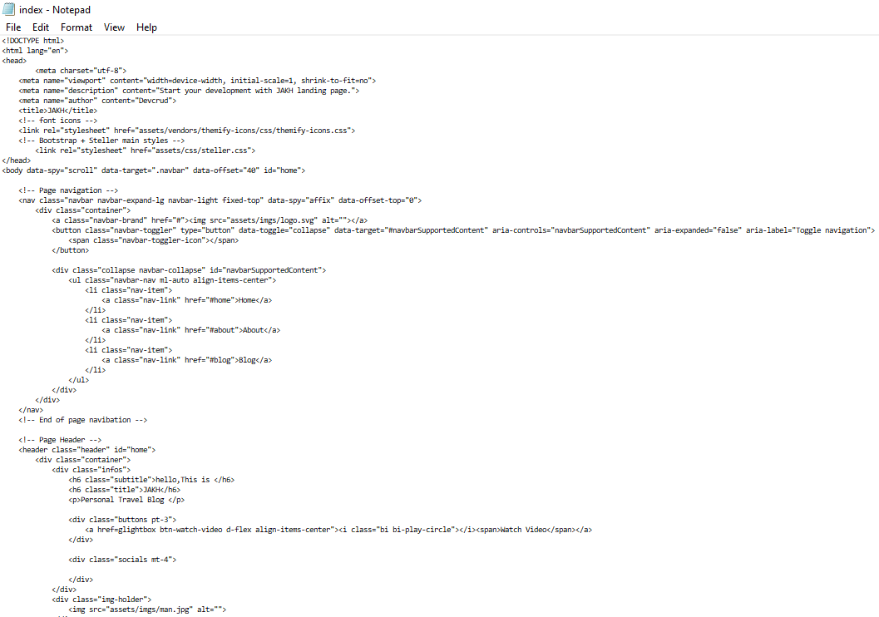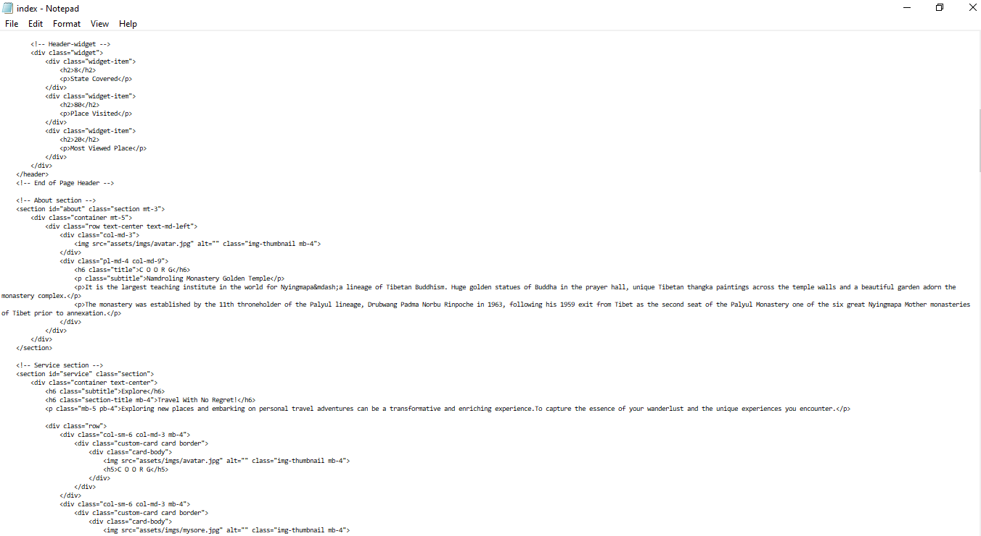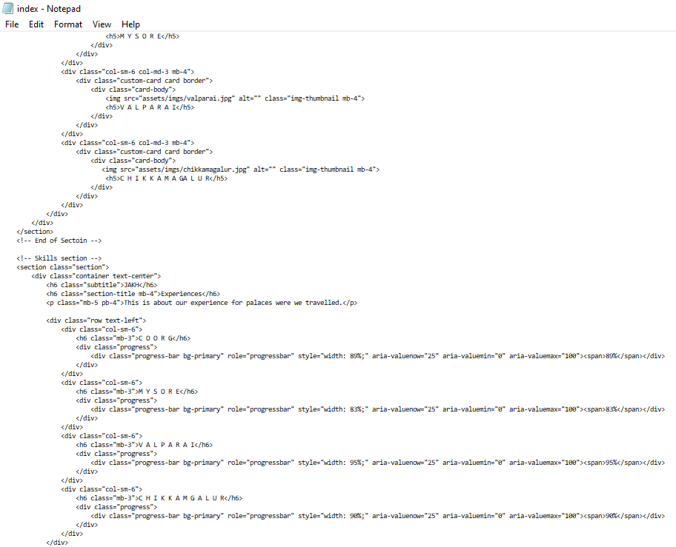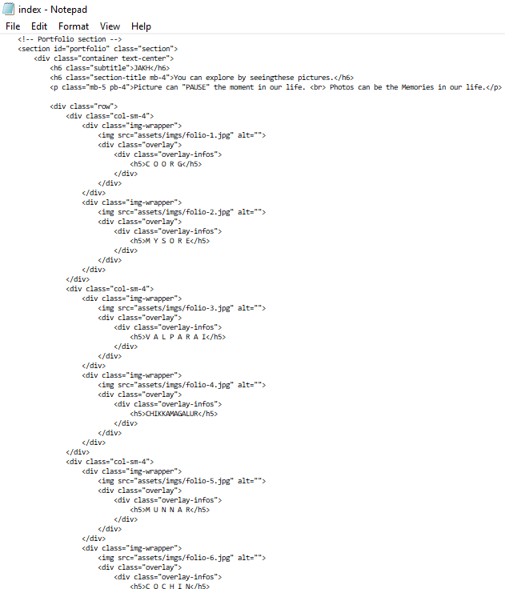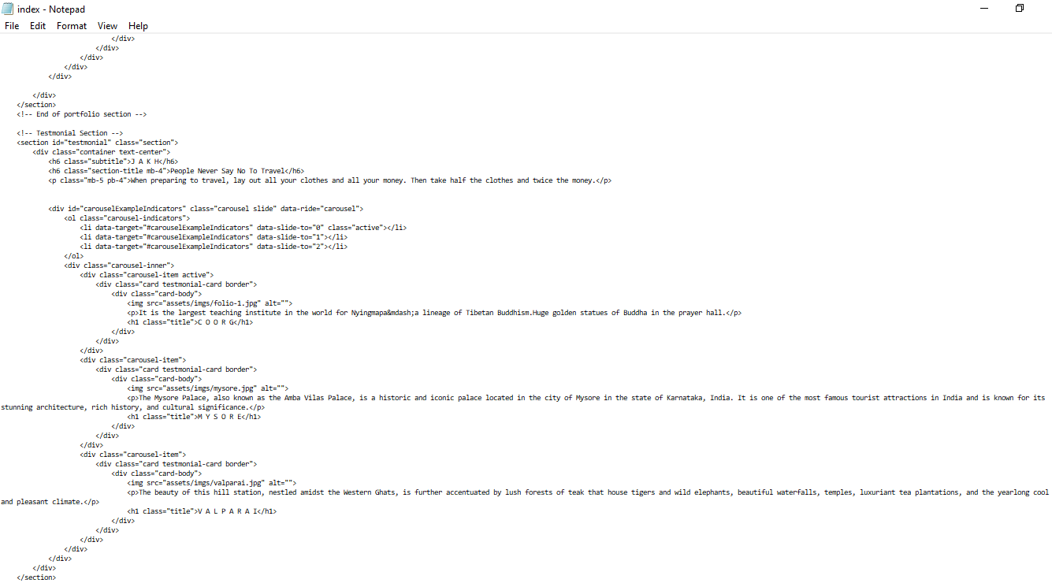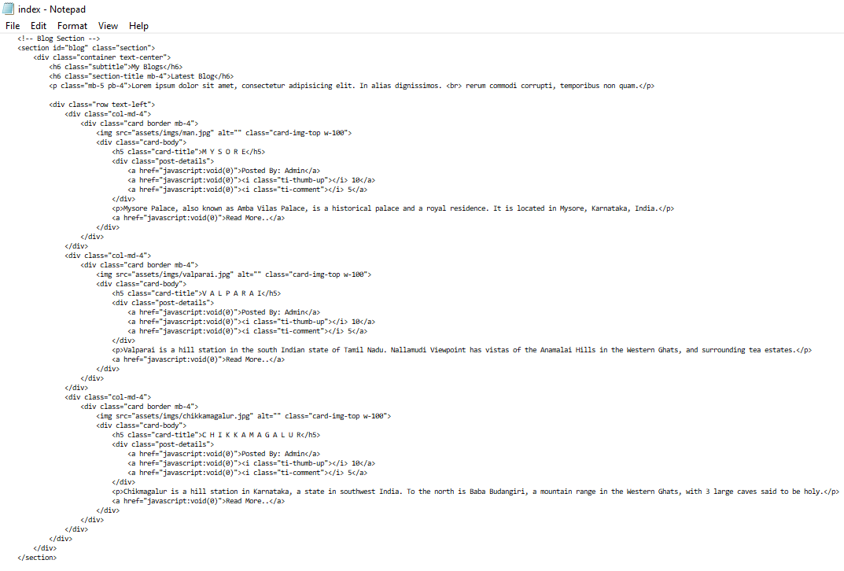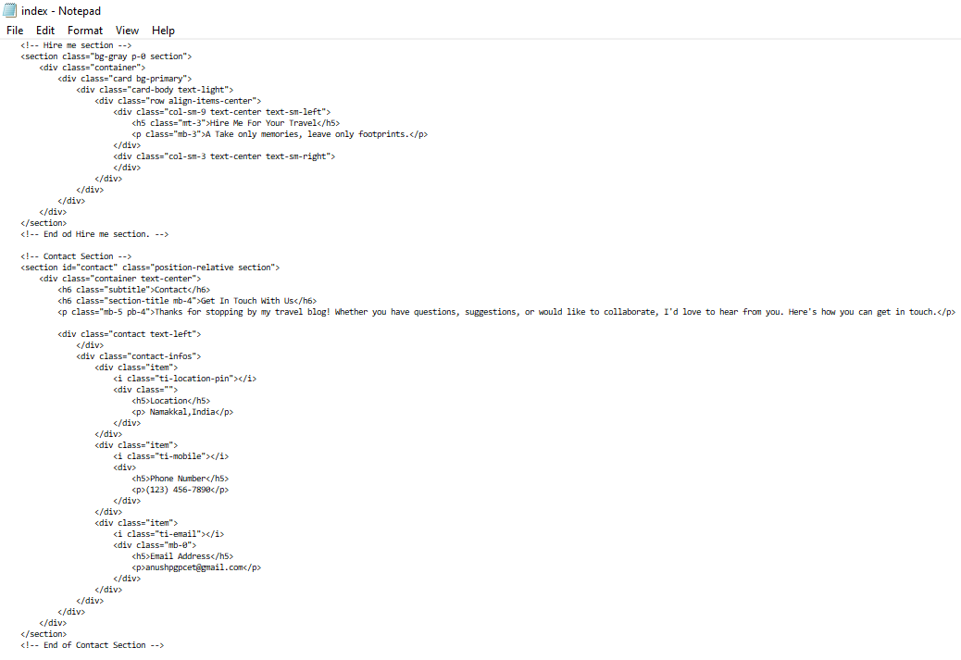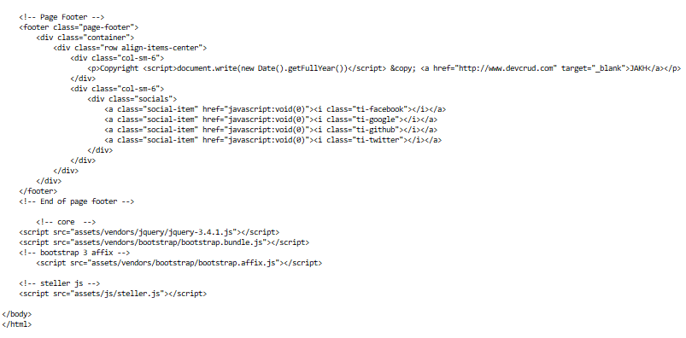

# Create a Static Web App:

* + In the IBM Cloud console, navigate to the "Resource List" or "Create Resource" section and search for "Static Web App."
  + Create a new Static Web App and follow the prompts to set it up. You'll be asked to provide information about your app, such as its name, description, and region.

Creation of bucket:

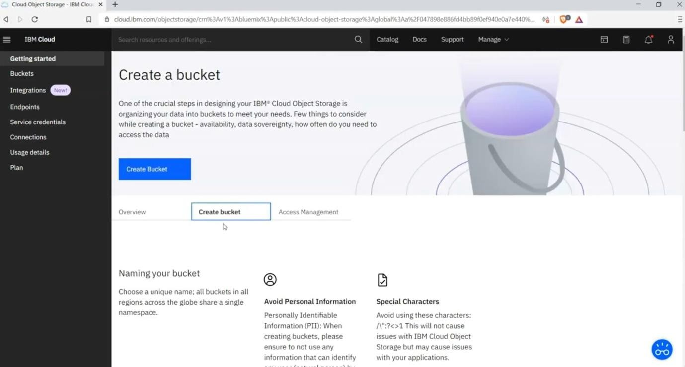

# 

# Set Up the Repository:

Choose your preferred repository hosting service (e.g., GitHub, Bitbucket) and connect it to your IBM Cloud account.

Select the repository where you'll store your blog's source code (HTML, CSS, and other assets).

Repository:

<https://github.com/HariharanPGP/Nmprojects.git>

HOSTED ON GIT:

<https://hariharanpgp.github.io/Nmprojects/>

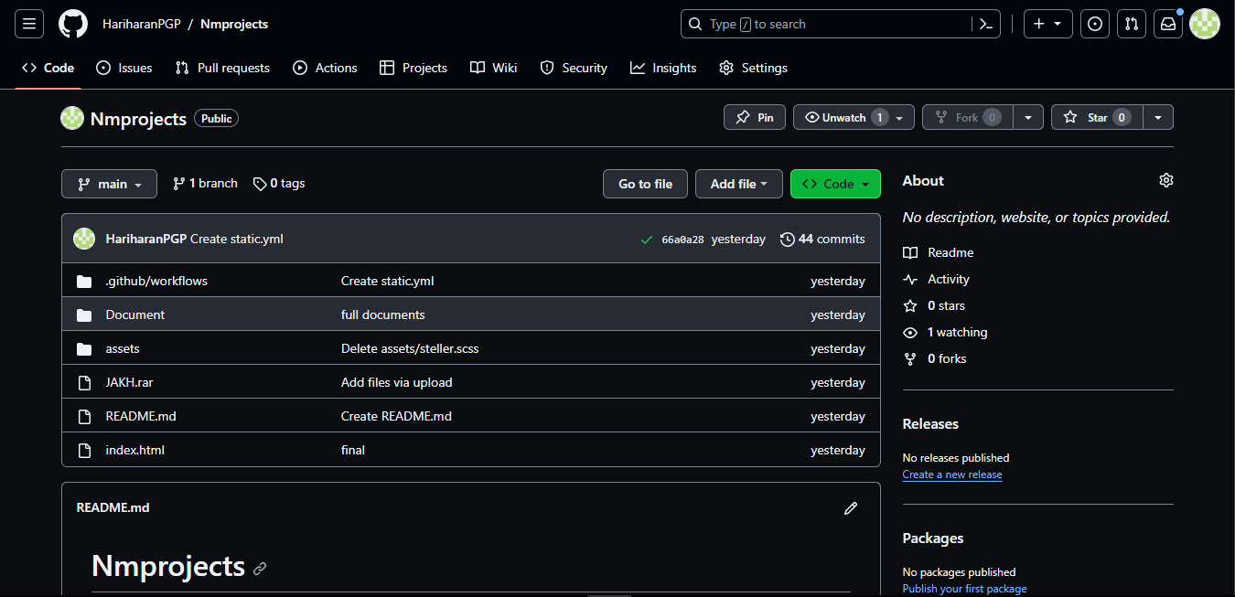

# Phase 4: Testing and Deployment

- Test the blog's functionality, responsiveness, and user experience.

- Gather feedback from testers and make necessary improvements.

- Deploy the blog to IBM Cloud, ensuring it's accessible to users.

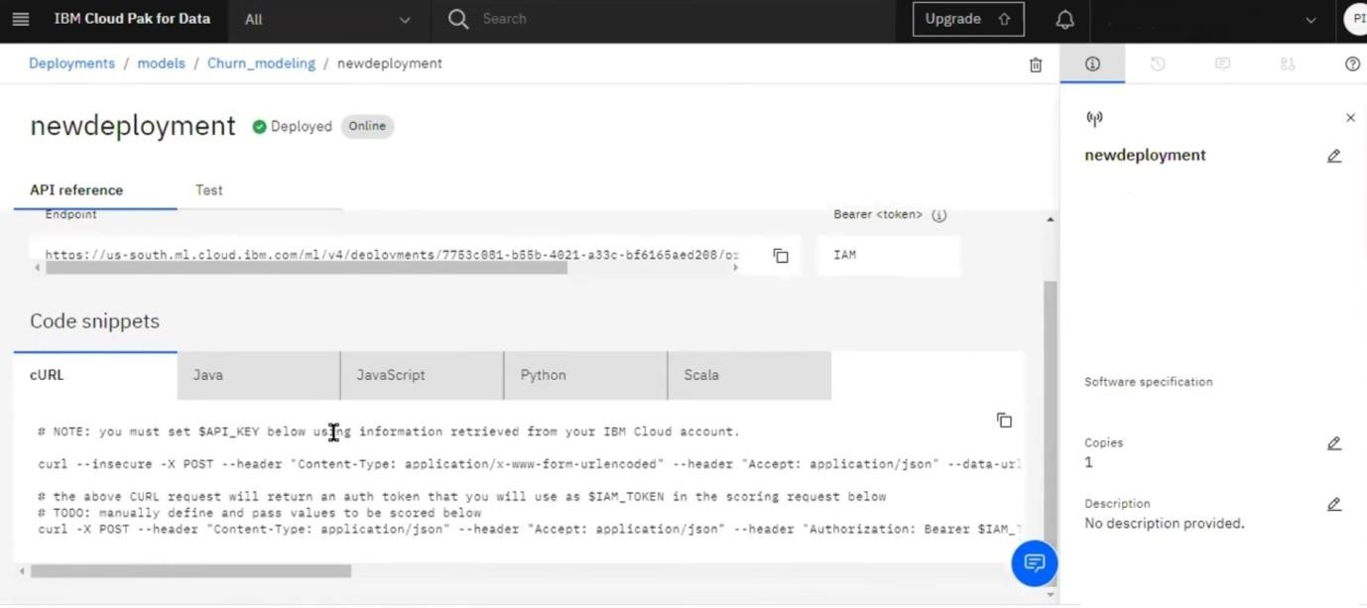- Implement continuous deployment for future updates.

# Phase 5: Content Management and Growth

- Continue creating and adding travel content to the blog.

- Manage and update content using the chosen CMS or site generator.

- Promote the blog to attract a readership and engage with the audience.